Lab Deliverable 1 C# Basics

Part II

- Write a program to accept a name and display the same.

Solution:
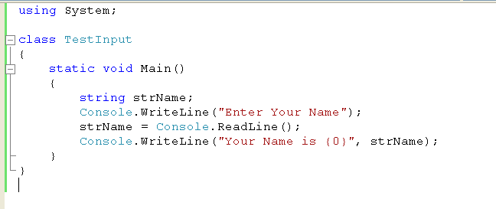

The output of the program is as shown in Figure 1.1.

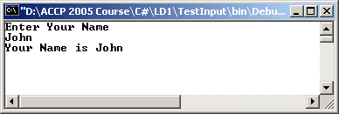

Figure 1.1: Output of TestInput.cs

- Write a program that accepts a number between 1 and 7 from the user and returns the corresponding day of a week. (1 - Monday, 2 -Tuesday and so on)

Solution:

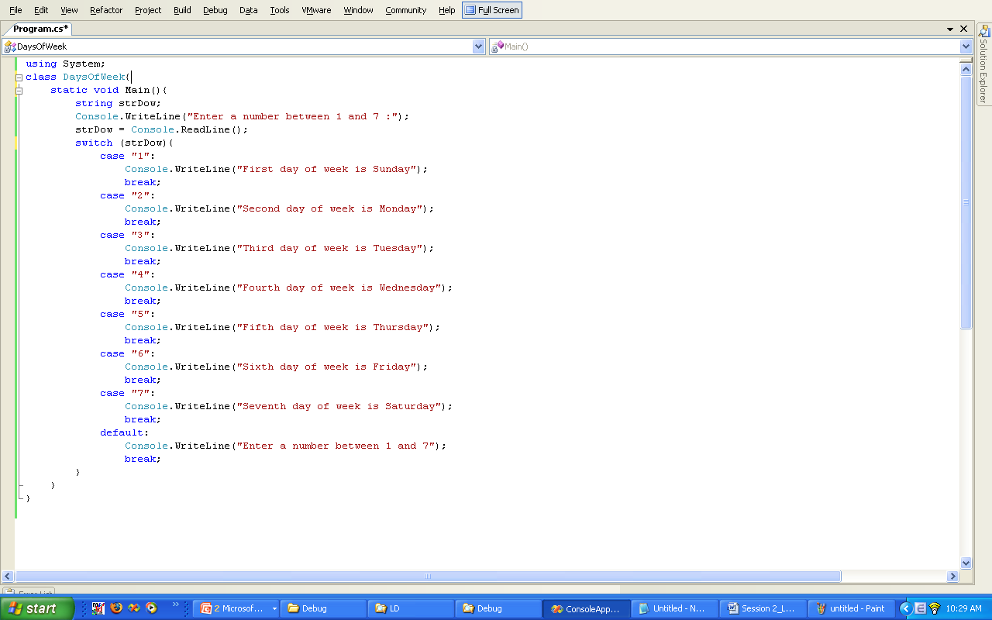

The output of the program is as shown in Figure 1.2.

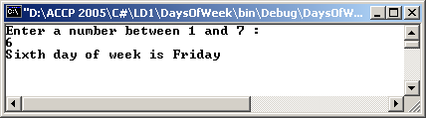

Figure 1.2: Output of DaysOfWeek.cs

- Write a program that calls a method to find the square of 10.

Solution:
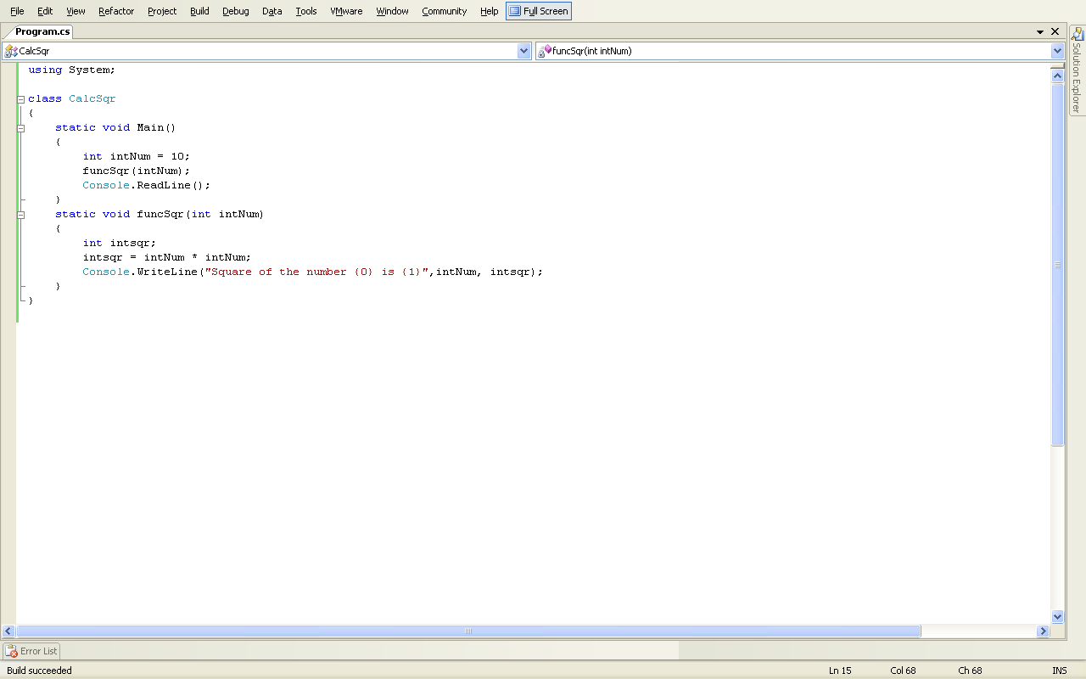

The output of the program is as shown in Figure 1.3.

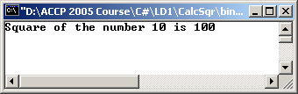

Figure 1.3: Output of CalcSqr.cs

- Write a program to display the first 10 multiples of 5.

Solution:

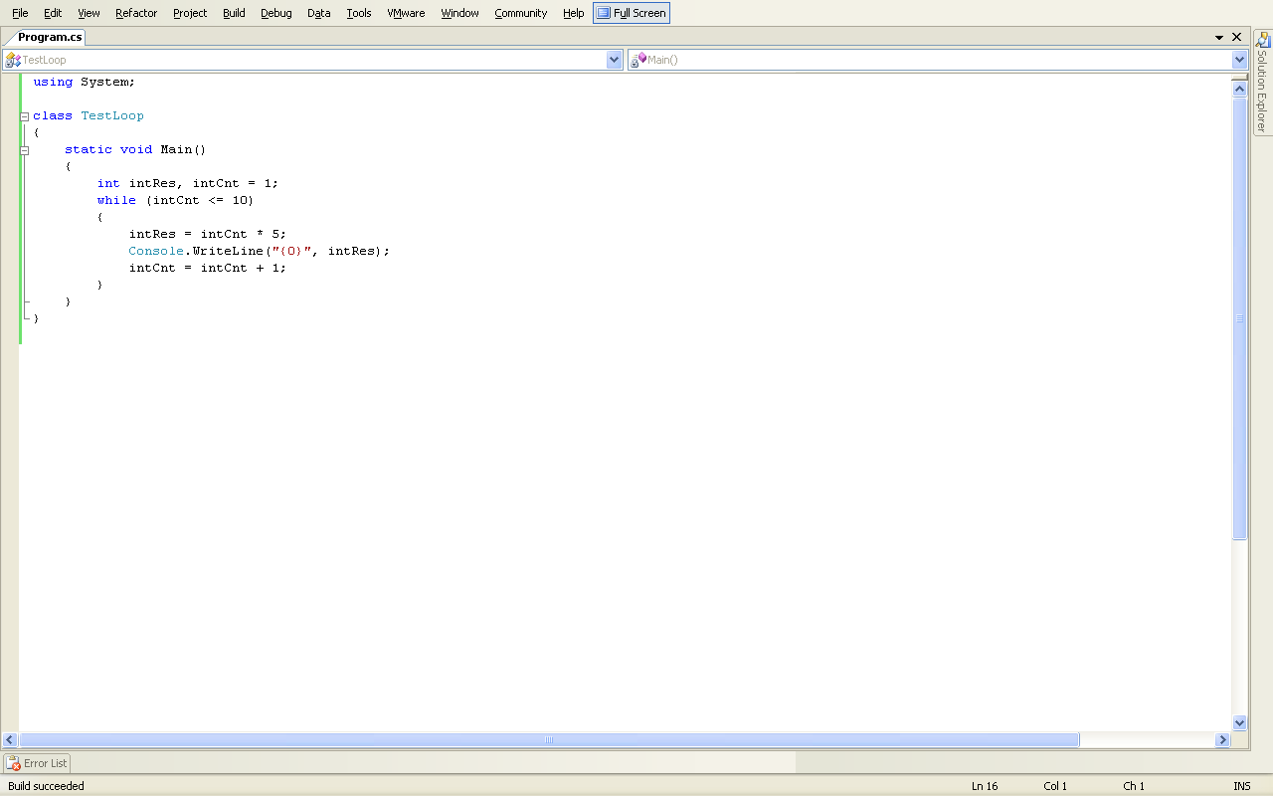
The output of the program is as shown in Figure1.4.
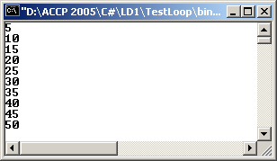

Figure 1.4: Output of TestLoop.cs

- Write a program to list the first 10 prime numbers.

Solution:
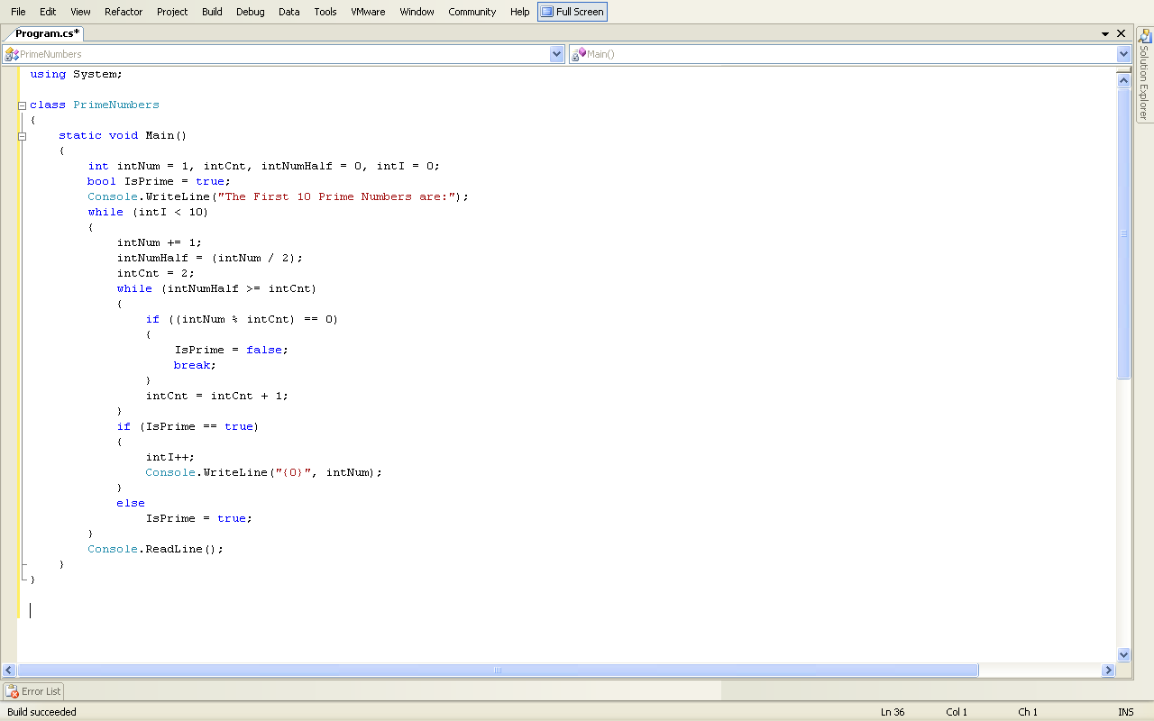

The output of the program is as shown in Figure 1.5.

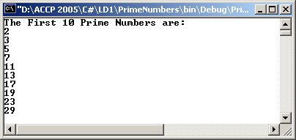

Figure 1.5: Output of PrimeNumbers.cs

Do It Yourself

- Write a program to accept a number and display whether it is odd or even.

Solution:

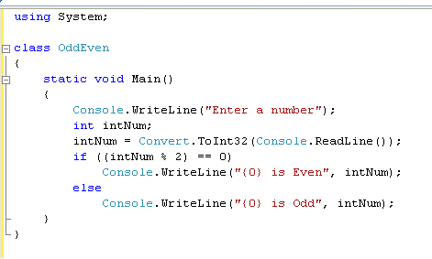

The output of the program is as shown in Figure1.6.

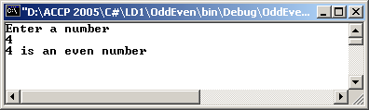

Figure 1.6: Output of OddEven.cs

- Write a program to accept a character as input from the user. If the letter input is any one out of “a”, “e”, “i”, “o”, or “u” then display a message “You have input, Vowel” else display “This is not a Vowel”.

Solution:
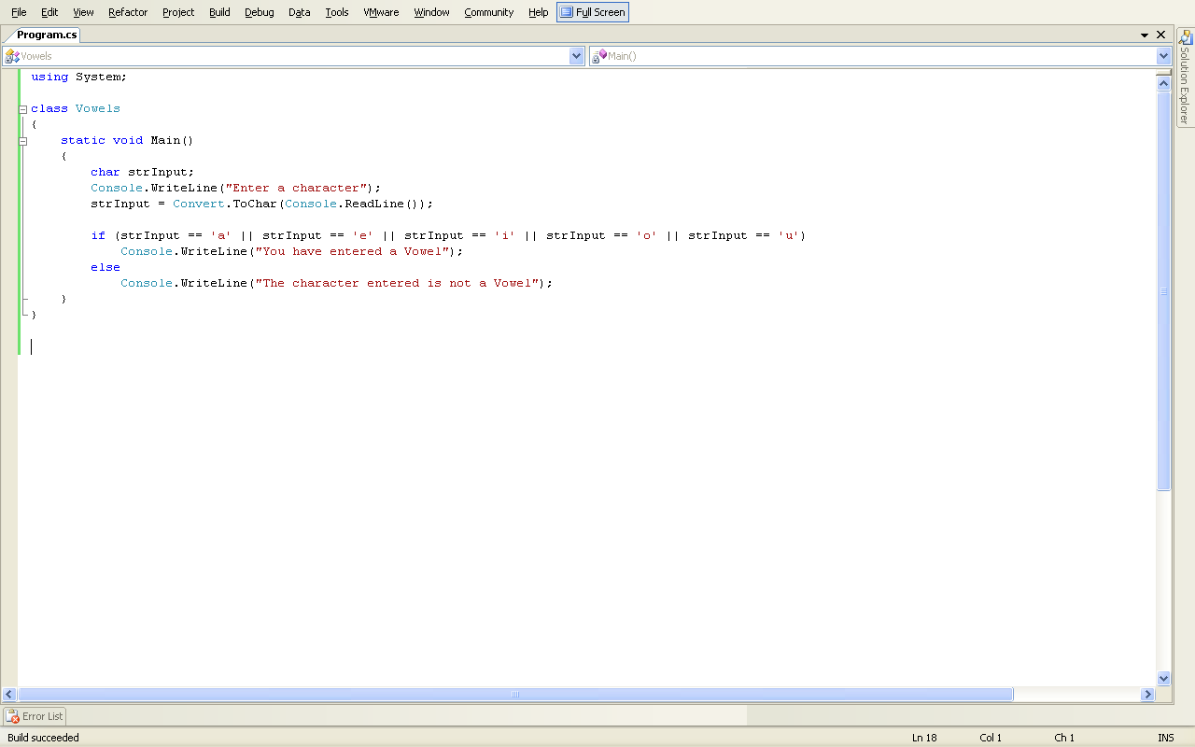

The output of the program is as shown in Figure1.7.

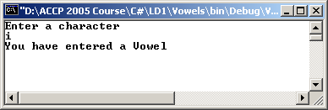

Figure 1.7: Output of Vowels.cs

